CAEF8QBPCAEF8QBP

**ELECTED**

**OFFICIALS**

**Robeson County Board of Elections**

**800 North Walnut Street**

**Lumberton, NC 28358**

**(910) 671-3080**

**(910) 737-5094 (fax)**

02/28/2020

**ELECTED OFFICIALS**

**ROBESON COUNTY**

**TERM**

**OFFICE ELECTED OFFICIALS AFFILIATION LENGTH EXPIRES**

**GOVERNOR** Roy Cooper, III **(D) 4 yrs 2020**

Office of the Governor

20301 Mail Service Center

Raleigh, NC 27699

(919) 733-4240

(919) 733-2120 – fax

**LIEUTENANT** Dan Forest **(R) 4 yrs 2020**

**GOVERNOR** Office of the Lieutenant Governor

20401 Mail Service Center

Raleigh, NC 27699

(919) 733-7350

(919) 733-6595-Fax

[lt.gov@nc.gov](mailto:lt.gov@nc.gov)

**ATTORNEY** Josh Stein **(D) 4 yrs 2020**

**GENERAL** Office of the Attorney General

9001 Mail Service Center

Raleigh, NC 27699

(919) 716-6400

(919) 716-6750-Fax

**AUDITOR** Beth A. Wood **(D) 4 yrs 2020**

NC Office of the State Auditor

20601 Mail Service Center

Raleigh, NC 27699

(919) 807-7500

(919) 807-7647-Fax

beth_wood@ncauditor.

**COMMISSIONER** Steve Troxler **(R) 4 yrs 2020**

**OF AGRICULTURE** NC Department of Agriculture

1001 Mail Service Center

Raleigh, NC 27699

(919) 707-3000

**COMMISSIONER** Mike Causey **(R) 4 yrs 2020**

**OF INSURANCE** NC Department of Insurance

1201 Mail Service Center

Raleigh, NC 27699

(800) 546-5664 NC ONLY

(919) 807-6750 OUTSIDE NC

 **TERM**

**OFFICE ELECTED OFFICIALS AFFILIATION LENGTH EXPIRES**

**COMMISSIONER** Cherie K. Berry **(R) 4 yrs 2020**

**OF LABOR** NC Department of Labor

1101 Mail Service Center

Raleigh, NC 27699

(919) 807-2796

1-800 NC LABOR

**SECRETARY OF** Elaine Marshall **(D) 4 yrs 2020**

**STATE** Office of Secretary of State

PO Box 29622

Raleigh, NC 27626

(919) 807-2000

**SUPERINTENDENT** Mark Johnson **(R) 4 yrs 2020**

**OF PUBLIC** 6301 Mail Service Center

**INSTRUCTION** Raleigh, NC 27699

(919) 807-3430

(919) 807-3445 –Fax

**TREASURER** Dale Folwell **(R) 4 yrs 2020**

3200 Atlantic Ave

Raleigh, NC 27604

(919) 508-5176

**US SENATOR** Thomas Rowland Tillis  **(R) 6 yrs 2020**

16116 North Point Road

Hunterville, NC 28078

Richard Burr **(R) 6 yrs 2022**

217 Russell Senate Ofc. Bldg.

Washington, DC 20510

(202) 224-3154

**CLERK OF** Shelena Smith  **(D) 4 yrs 2022**

**SUPERIOR** 540 Pine Lake Park Road

**COURT** Pembroke, NC 28372

**DISTRICT** Matt Scott **(D) 4 yrs 2022**

**ATTORNEY** 1708 University Road

Pembroke, NC 28372

**REGISTER OF** Vicki L. Locklear **(D) 4 yrs 2020**

**DEEDS** 354 Kensington Street

Lumberton, NC 28358

(910) 671-3044

**TERM**

**OFFICE ELECTED OFFICIALS AFFILIATION LENGTH EXPIRES**

**SHERIFF** Burnis Wilkins **(D) 4 yrs 2022**

4917 White Oak Drive

Lumberton, NC 28358

**13TH** Danny Britt  **(R) 2 yrs 2020**

**SENATORIAL** 1101 N. Walnut Street

Lumberton, NC 28358

**CONGRESSIONAL** Dan Bishop **(R) 2 yrs 2020**

**DISTRICT** 16 West Jones Street

**(9th DISTRICT)** Raleigh, NC 27601

**HOUSE OF REPRESENTATIVES**

**66TH DISTRICT** Ken Goodman **(D) 2 yrs 2020**

832 Williamsburg Dr.,

Rockingham, NC 28379

**48TH DISTRICT** Garland E. Pierce  **(D) 2 yrs 2020**

21981 Buie Street

Wagram, NC 28356

H: (910) 369-2844

Bus: (910) 273-1098

**47TH DISTRICT** Charles Graham **(D) 2 yrs 2020**

479 Bee Gee Road

Lumberton, NC 28358

H: (910) 739-3969

**46th DISTRICT** Brenden Jones **(R)** **2 yrs 2020**

329 S. US Highway 701

Tabor City, NC 28463

H: (910) 654-3734

**JUDICIAL OFFICES**

[](http://constitutionallyspeaking.co.za/wp-content/uploads/2013/02/blind-justice.gif)**SUPERIOR COURT** Robert (Frank) Floyd, Jr. **(D) 8 yrs 2020**

**DISTRICT 16B** 200 Martin Street

Fairmont, NC 28340

James Gregory Bell **(D) 8 yrs 2020**

4309 N. Walnut Street Appointed 01/16/2009

Lumberton, NC 28358

**DISTRICT COURT** Brooke Locklear Clark **(D) 4 yrs 2022**

**JUDGE 16B** PO Box 580

Pembroke, NC 28372

Vanessa Burton **(D ) 4 yrs 2022**

604 W. 31st Street

Lumberton, NC 283**58**

Angelica McIntyre **(D) 4 yrs 2022**

1917 N. Walnut Street Lumberton, NC 28358

Judith Daniels **(D) 4 yrs 2020**

347 Forest Road

Lumberton, NC 283758

William Jeffery Moore **(D) 4 yrs 2020**

388 W L Moore Rd. Appointed 03/06/2009

Maxton, NC 28364



**COMMISSIONERS**

**TERM**

**OFFICE ELECTED OFFICIALS AFFILIATION LENGTH EXPIRES**

**DISTRICT 1** Jerry L. Stephens, Sr., **(D) 4 yrs 2020**

 PO Box 1741

130 Tarheel Road

Lumberton, NC 28359

H: (910) 671-0431

**DISTRICT 2**

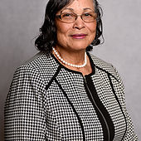 Pauline Campbell **(D) 4 yrs 2022**

1860 Turkey Branch Road

Fairmont, NC 28340

H: (910)

Bus: (910)

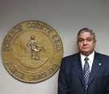**DISTRICT 3** Roger D. Oxendine **(D) 4 yrs 2020**

5671 NC Hwy 130 E

Rowland, NC 28383

Bus: (910) 628-6238

Res: (910) 628-8667

**DISTRICT 4** **(D) 4 yrs 2022**

 Faline Dial

2818 Hezekiah Road

Pembroke, NC 28372

Res: (910) 827-1005

**DISTRICT 5** Raymond Cummings **(D) 4 yrs 2020**

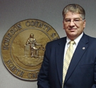 2460 Whistling Rufus Road

Pembroke, NC 28372

Bus: (910) 739-4743 cummingsr.psrc@robeson.k12.nc.us

Res: (910) 521-4934

**DISTRICT 6** David Edge **(R) 4 yrs 2022**

1114 Powersville Road Lumberton, NC  28358    
910-738-8003 Home   
910-258-1166 Cell [David edge@yahoo.com](mailto:David%20edge@yahoo.com)  
2010 - Present

**DISTRICT 7** H. T. (Tom) Taylor, Jr. **(D) 4 yrs 2020**

 232 West Road

Lumberton, NC 28358

Bus: (910) 739-7516

Res: (910) 738-4460

**DISTRICT 8** Lance Herndon **(D) 4 yrs 2022**

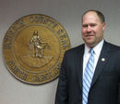 1369 E. Parkton Tobemory Road

Parkton, NC 28371

Res: (910) 858-0214



**BOARD OF EDUCATION**

**NON PARTISAN**

**TERM**

**DISTRICT ELECTED OFFICIALS LENGTH EXPIRES**

**#1** Vacant **4 yrs 2020**

**#2** Brenda Fairley **4 yrs 2022**

PO Box 441

Maxton, NC 28364

H: (910) 390-4119

brendasfairley@yahoo.com

**#3** Linda O. Emanual **4 yrs 2022**

852 Saddletree Road

Lumberton, NC 28360

H: (910) 734-4559

**#4** Charles Bullard **4 yrs 2020**

167 Jude Road

Maxton, NC 28364

H: (910) 521-5609

**#5** Craig Lowry **4 yrs 2020**

47 Ernest Lowry Road

Pembroke, NC 28372

**#6** Mike Smith **4 yrs 2022**

516 N. Vance Street

Red Springs, NC 28377

H: (910) 843-2735

mikesmith2656@aol.com

**#7** Steve Martin  **4 yrs 2020**

365 Rodeo Drive PO Box 3672

Lumberton, NC 28359

(910) 738-2864

martins.psrc@robeson.k12.nc.us

**#8** Dwayne Smith **4 yrs 2022**

5105 Live Oak Lane

Lumberton, NC 28358

H: (910) 738-9986 W: (910) 738-4295

[smithd.psrc](mailto:smithd.psrc@robeson.k12.nc.us)[@](mailto:smithd.psrc@m)robeson.k12.nc.us

**TERM**

**DISTRICT ELECTED OFFICIALS LENGTH EXPIRES**

**BOARD OF EDUCATION**

**AT LARGE MEMBERS**

Randy Lawson **4 yrs 2020**

653 Long Branch Drive

Lumberton, NC 28358

(910) 734-5807

John A. Campbell **4 yrs 2020**

3735 Abby Lane

Lumberton, NC 28358

Work: (910) 671-6000

Res: (910) 739-2624

[campbellj.psrc@robeson.k12.nc.us](mailto:campbellj.psrc@robeson.k12.nc.us)

Brian Freeman **4 yrs 2020**

115 S. Peachtree Street

Red Springs, NC 28377

Work: (910) 424-7200

Cell: (910) 258-3006

**The Board of Education of the Public Schools of Robeson County is made up of eleven members eight of whom are elected by district and three at-large.   They are elected on a non-partisan basis during spring primary elections of even-numbered years.   Four district seats and the three at-large seats were filled in 2008.   Terms are for four years and the Board is reorganized during the first meeting in July.**

**The Board meets the second Tuesday of each month at 6:00 PM at the  Board of Education unless otherwise announced.   Public comment is entertained by the Board by reservation during this meeting.**

**Public Schools of Robeson County  
410 Caton Road  
Lumberton, NC 28358**

**Telephone: 910.671.6000  
Fax: 910.671.6024**

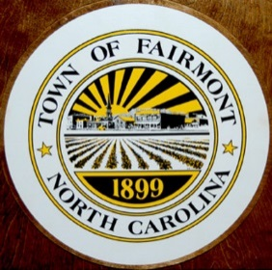**TOWN OF FAIRMONT**

**NON PARTISAN**

**TERM**

**OFFICE ELECTED OFFICIALS LENGTH EXPIRES**

**MAYOR** Bobby Charles Townsend **4 yrs 2021**

410 Jackson Street

Fairmont, NC 28340

H: (910) 628-7132

**COUNCIL** Terry Evans **4 yrs 2021**

104 W.Pine Street

Fairmont, NC 28340

H: (910) 506-6851

**COUNCIL** Heather Seibles **4 yrs 2023**

310 Martin Street

Fairmont, NC 28340

(910)

**COUNCIL** Felecia McLean-Kesler **4 yrs 2021**

512 Happy Hill Road

Fairmont, NC 28340

H: (910)

**COUNCIL** Jeffery J. McCree **4 yrs 2023**

301 East Pine Street

Fairmont, NC 28340

H: (910) 628-1406

**COUNCIL** Charles Kemp **4 yrs 2023**

405 N. Main Street

Fairmont, NC 28340

740-0277

**COUNCIL** Antonia Monte McCallum **4 yrs 2021**

413 Madison Street

Fairmont, NC 28340

H: (919) 649-1670

**TOWN OF LUMBER BRIDGE**

**NON PARTISAN**

**TERM**

**OFFICE ELECTED OFFICIALS LENGTH EXPIRES**

**MAYOR** William (Skip) Davis **4 yrs 2021**

PO Box 299

Lumber Bridge, NC 28357

H: (910) 424-8515

**COUNCIL** Alan Brunnet  **4 yrs 2023**

107 School Street

PO Box 65

Lumber Bridge, NC 28357

H: (910) 843-1064

Cell: (910) 263-0788

**COUNCIL** Lena Canady  **4 yrs 2021**

102 E. Main Street

Lumber Bridge, NC 28357

Bus (910) 843-3118

Home (910) 843-4596

**COUNCIL** Kenneth Jordan **4 yrs 2021**

204 Church Street

Lumber Bridge, NC 28357

H: (910) 843-9455

**COUNCIL** Randy Russ **4 yrs 2023**

PO Box 165

Lumber Bridge, NC 28357

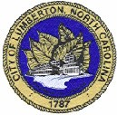**CITY OF LUMBERTON**

**(NON PARTISAN)**

**TERM**

**OFFICE ELECTED OFFICIALS LENGTH EXPIRES**

**MAYOR** Bruce Davis  **4 yrs 2023**

PO Box 1147

Lumberton, NC 28359

739-7496

**COUNCIL #1** Leroy Rising **4 yrs 2023**

301 Sandlin Drive

Lumberton, NC 28358

738-2286

**COUNCIL #2** Melissa Nealy Robinson **4 yrs 2021**

231 Meadow Road

Lumberton, NC 28358

910-734-0753

**COUNCIL #3** John R. Carroll, Jr. **4 yrs 2021**

1306 Hardin Road

Lumberton, NC 28358

734-5516

**COUNCIL #4** Karen Higley **4 yrs 2023**

PO Box 2395

Lumberton, NC 28359

740-3406

**COUNCIL #5** John Cantey, Jr. **4 yrs 2021**

310 Bullard Street

Lumberton, NC 28358

H: (910) 374-7469

**COUNCIL #6** Chris Howard, Jr. **4 yrs 2023**

127 Page Street

Lumberton, NC 28358

608-3024

**COUNCIL #7** Eric Chavis **4 yrs 2023**

2960 Bragg Street

Lumberton, NC 28358

740-3277

**COUNCIL #8** Owen Thomas **4 yrs 2021**

1701 N. Chestnut Street

Lumberton, NC 28358

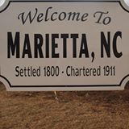**TOWN OF MARIETTA**

**(NON PARTISAN)**

**TERM**

**OFFICE ELECTED OFFICIALS LENGTH EXPIRES**

**MAYOR** Justin Oliver **4 yrs 2021**

2479 Olivet Church Road

PO Box 99

Marietta, NC 28362

Bus.: (910) 272-3600

Home: (910) 628-6556

**COUNCIL** John F. Bare **4 yrs 2021**

PO Box 14

Marietta, NC 28362

H: (910) 628-9368

**COUNCIL** Walter Powell **4 yrs 2021**

PO Box 130

Marietta, NC 28362

H: (910) 628-9548

**COUNCIL** Donna O. Stubbs **4 yrs 2021**

2656 Olivet Church Road

PO Box 145

Fairmont, NC 28340

H: (910) 628-8103

**COUNCIL** Mae Thelma Williams **4 yrs 2021**

2398 Marietta Road

PO Box 62

Marietta, NC 28340

H: (910) 628-6093

**Session Law 2016-69 – Senate Bill 890**

After 2017 Election, Mayor will run again in 2021 change to a 4 year term.

Council running in 2017 will run again in 2021 for a 4 year term.

Council term expiring in 2019 will run in 2021 instead. **ALL IN A FOUR (4) YEAR TERM.**

No Election in 2019 for Marrietta.

**NO ABSENTEE**

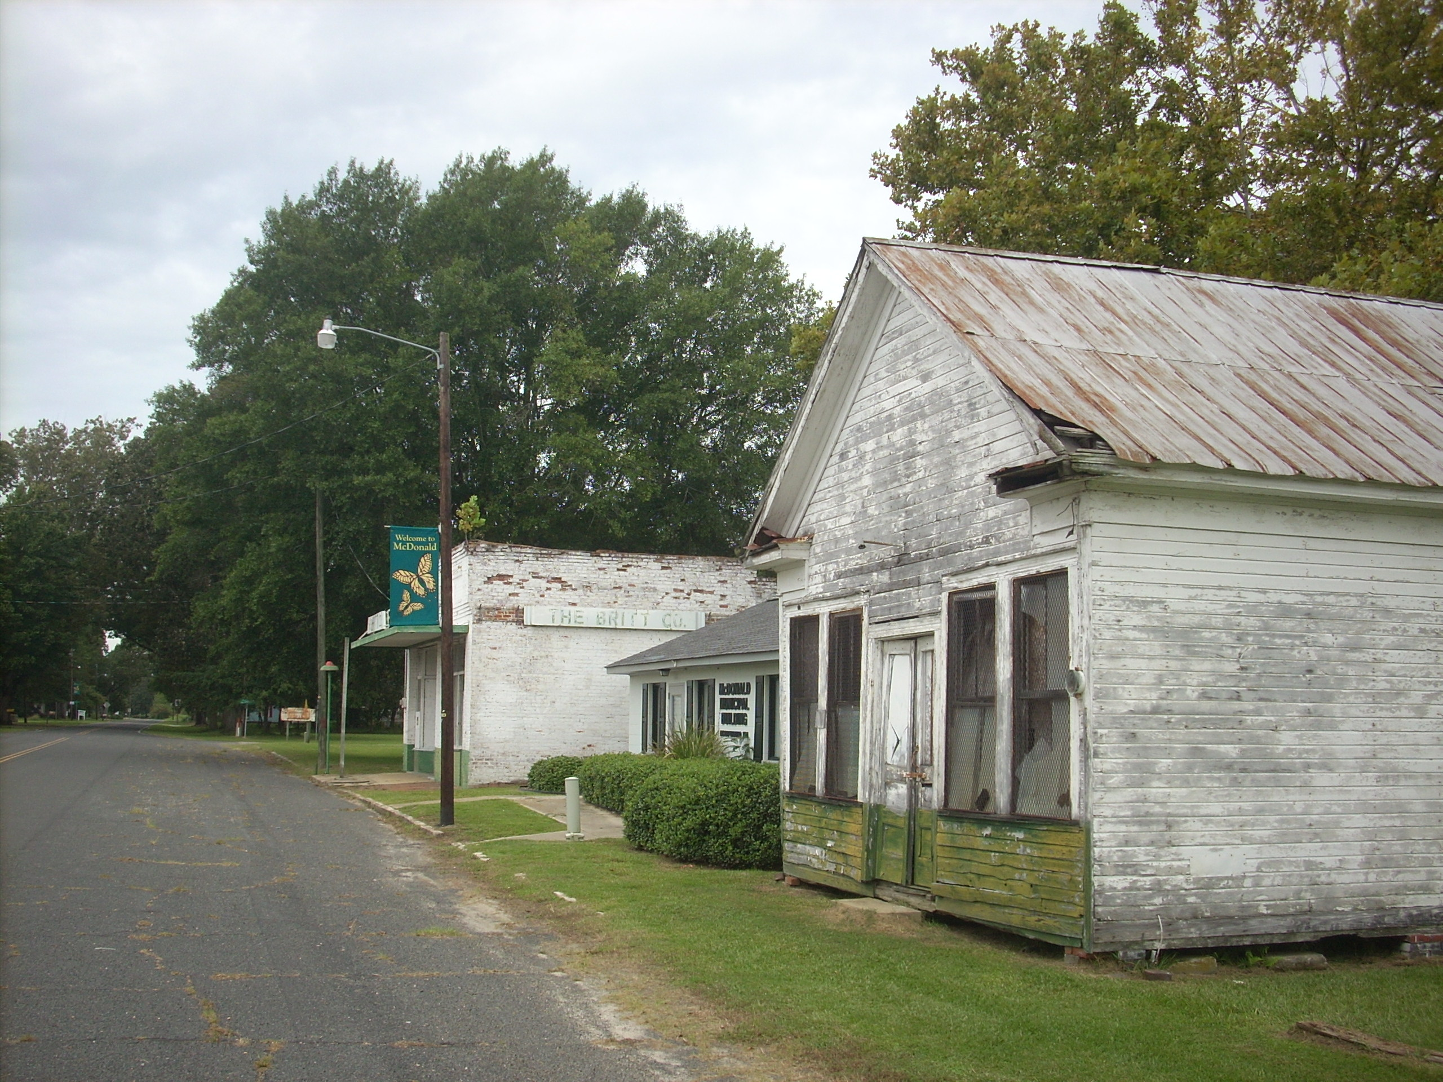**TOWN OF MCDONALD**

**(NON PARTISAN)**

**TERM**

**OFFICE ELECTED OFFICIALS LENGTH EXPIRES**

**MAYOR** James R. Taylor **4 yrs 2023**

132 North 2nd Street

McDonald, NC 28340

H: (910) 628-6606

W: (910) 422-9002

**COUNCIL** Dannie M. Bacot **4 yrs 2023**

4720 E. McDonald Road

Fairmont, NC 28340

H: (910) 628-0574

**COUNCIL** William A. Britt **4 yrs 2023**

4620 E McDonald Road

Fairmont, NC 28340

**COUNCIL** George Dean Carter **4 yrs 2023**

PO Box 711

Fairmont, NC 2834

**In 2015 all will run for office.**

**They will not run again until 2019.**

**General Assembly of North Carolina Session 2013**

**Session Law 2014-24 Senate Bill 867**

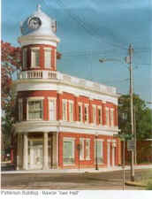**TOWN OF MAXTON**

**(NON PARTISAN)**

**TERM**

**OFFICE ELECTED OFFICIALS LENGTH EXPIRES**

**MAYOR** Paul Davis **4 yrs 2023**

104 N. Main Street

Maxton, NC 28364

**COUNCIL** Paul McDowell **4 yrs 2023**

12061 Cameron Way

Maxton, NC 28364

844-9656

**COUNCIL** Virgil L. Hutchinson **4 yrs 2021**

407 Lombard Street

Maxton, NC 28364

**COUNCIL** Toni Bethea **4 yrs 2023**

303 Carolina Street

Maxton, NC 28340

**COUNCIL** Victor Reginald Womack, Sr. **4 yrs 2021**

713 Mccaskil Street

Maxton, NC 28364

**COUNCIL** Elizabeth Gilmore **4 yrs 2023**

598 NC71 Hwy 71

Maxton, NC 28364

844-3112

[](http://www.google.com/url?url=http://www.zazzle.com/north%2Bcarolinian%2Bposters&rct=j&frm=1&q=&esrc=s&sa=U&ei=B8uqU5-dGMGZyAS_-IKgCQ&ved=0CCoQ9QEwCjgU&usg=AFQjCNEoTbFDjOZA8hhHdJXgMixKe-ac_Q)**TOWN OF ORRUM**

**(NON PARTISAN)**

**TERM**

**OFFICE ELECTED OFFICIALS LENGTH EXPIRES**

**MAYOR** Wilton Caulder **4 yrs 2021**

5050 Atkinson Road

PO Box 31

Orrum, NC 28369

H: (910) 628-0882

**COUNCIL** Dannie Anderson **4 yrs 2021**

159 Charitable Drive

PO Box 70

Orrum, NC 28369

**COUNCIL** Jessie Stephens **4 yrs 2021**

PO Box 31

Orrum, NC 28369

**COUNCIL** Gene Horne **4 yrs 2021**

PO Box 53

Orrum, NC 28369

**COUNCIL** Cleo Smith **4 yrs 2021**

166 Charitable Drive

PO Box 14

Orrum, NC 28369

**In 2017 all will run for office.**

**They will not run again until 2021.**

**General Assembly of North Carolina Session 2017**

**Senate Bill 288**

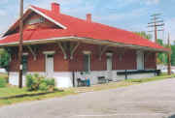**TOWN OF PARKTON**

**(NON PARTISAN)**

**TERM**

**OFFICE ELECTED OFFICIALS LENGTH EXPIRES**

**MAYOR** Al McMillan **2 yrs 2021**

341 N. Washington Street

PO Box 234

Parkton, NC 28371

H: (910) 858-3225

Cell: (910) 674-6949

**ALDERMAN** Christopher Carlson **2 yrs 2021**

197 S. Fayetteville Road

Parkton, NC 28371

H: (910) 858-3090

**ALDERMAN** Robin Hill **2 yrs 2021**

202 South Fayetteville Street

PO Box 338

Parkton, NC 28371

H: (910) 858-3049

**ALDERMAN** Doris Underwood **2 yrs 2021**

346 W Third Street

PO Box 233

Parkton, NC 28371

H: (910) 858-3542

**ALDERMAN** Tony McVickers **2 yrs 2021**

PO Box 584

Parkton, NC 28371

**ALDERMAN** David Register **2 yrs 2021**

220 David Parnell Street

Parkton, NC 28371

**TOWN OF PEMBROKE**

******(NON PARTISAN)**

**TERM**

**OFFICE ELECTED OFFICIALS LENGTH EXPIRES**

**MAYOR** Greg Cummings **4 yrs 2023**

622 Union Chapel Road

Pembroke, NC 28372

**COUNCIL** Channing Jones **4 yrs 2021**

PO Box 543

Pembroke, NC 28372

910- 775-9519

**COUNCIL** Ryan Sampson **4 yrs 2023**

813 Harry West Lane

Pembroke, NC 28372

910-733-2225

**COUNCIL** Theresa Locklear **4 yrs 2021**

413 Barker Street

Pembroke, NC 28372

910-736-8943

**COUNCIL** Larry McNeill **4 yrs 2023**

808 Harry West Lane

Pembroke, NC 28372

910-734-3763

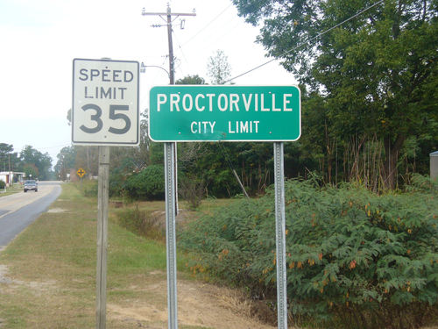**TOWN OF PROCTORVILLE**

**(NON PARTISAN)**

**TERM**

**OFFICE ELECTED OFFICIALS LENGTH EXPIRES**

**MAYOR** Michael Sealy **4 yrs 2023**

PO Box 247

314 S. Spruce Street

Proctorville, NC 28375

**COUNCIL** Alphonzo McRae **4 yrs 2023**

109 N. Spruce Street

PO Box 178

Proctorville, NC 28375

**COUNCIL** Lewis Allen Clyburn **4 yrs 2023**

107 South Cedar Street

PO Box 66

Proctorville, NC 28375

**COUNCIL** Virginia Ivey **4 yrs 2023**

PO Box 67

107 N. Stone Street

Proctorville, NC 28375

**In 2015 all will run for office.**

**They will not run again until 2019.**

**General Assembly of North Carolina Session 2013**

**Session Law 2014-25 Senate Bill 868**

[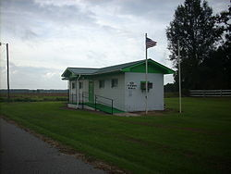](http://en.wikipedia.org/wiki/File:Raynham_Town_Hall.jpg)**TOWN OF RAYNHAM**

**(NON PARTISAN)**

**TERM**

**OFFICE ELECTED OFFICIALS LENGTH EXPIRES**

**MAYOR** Debra Lindsay Arnette **4 yrs 2021**

48 Union School Road

Rowland, NC 28383

B: (910) 739-8929

Cell: (910) 734-1527

**COUNCIL** Datry Hunt **4 yrs 2021**

162 Union School Road

Rowland, NC 28383

**COUNCIL** Martha Watts **4 yrs 2021**

35 Chelsea Drive

Rowland, NC 28383

**COUNCIL** Kathleen Lindsay **4 yrs 2021**

5548 US Hwy 301 South

Rowland, NC 28383

H: (910) 422-3097

B: (910) 739-8988

**In 2017 all will run for office.**

**They will not run again until 2021.**

**General Assembly of North Carolina Session 2013**

**Session Law 2014-25 Senate Bill 288**

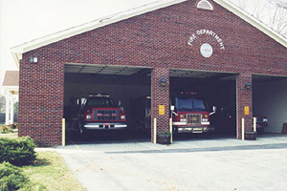**TOWN OF RED SPRINGS**

**(NON PARTISAN)**

**TERM**

**OFFICE ELECTED OFFICIALS LENGTH EXPIRES**

**MAYOR** Edward Henderson **2 yrs 2021**

216 W Sunset Drive

Red Springs, NC 28377

H: (910) 843-5865

**COUNCIL** C. L. Edmonds **4 yrs 2023**

105 Brooks Ave

Red Springs, NC 28377

887-5537

**COUNCIL** Neal Lea’kes **4 yrs 2021**

314 E Sunset Drive

Red Springs, NC 28377

**COUNCIL** Duron Burney **4 yrs 2023**

216 Richardson Street

Red Springs, NC 28377

843-5327

**COUNCIL** Caroline Sumpter **4 yrs 2023**

204 S.Peach Street

Red Springs, NC 28377

H: (910)

**COUNCIL** Elma (Ree) Marie Patterson **4 yrs 2021**

102 Harrington Street

Red Springs, NC 28377

**COUNCIL** Murray McKeithan **4 yrs 2021**

218 Hubert McLean Ave

Red Springs, NC 28377

H: (910) 843-3309



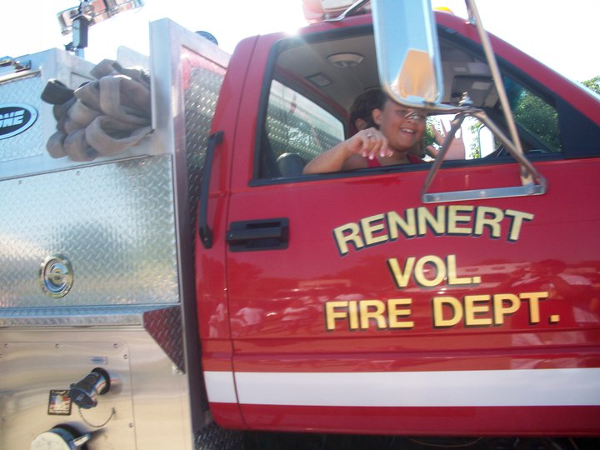**TOWN OF RENNERT**

**(NON PARTISAN)**

**TERM**

**OFFICE ELECTED OFFICIALS LENGTH EXPIRES**

**MAYOR** Elizabeth D. Locklear **4 yrs 2021**

74 Boots Road Unexpired term

Shannon, NC 28386

(910) 843-2646

**COUNCIL** Neal Locklear **4 yrs 2021**

60 Jasper Drive

Shannon, NC 28386

(910) 843-6752

**COUNCIL** Sabrina Colson **4 yrs 2023**

652 Pine Street

Shannon, NC 28386

**COUNCIL** Brenda F. Locklear **4 yrs 2023**

9259 Rennert Road

Shannon, NC 28386

H: (910) 843-3663

Cell: (910) 624-0845

**COUNCIL** Velenda Morgan **4 yrs 2021**

55 Morgan J Road

Shannon, NC 28386

**COUNCIL** Vivian W. McRae **4 yrs 2023**

669 Pine Street

Shannon, NC 28386

C: (910) 734-5198

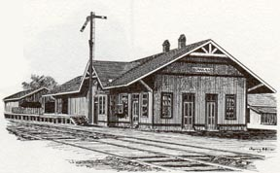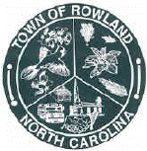**TOWN OF ROWLAND**

**(NON PARTISAN)**

**TERM**

**OFFICE ELECTED OFFICIALS LENGTH EXPIRES**

**MAYOR** Michelle Shooter **2 yrs 2021**

503 Godfrey Street

Rowland, NC 28383

**COUNCIL** Betty J. Boyd **4 yrs 2023**

201 North Hickory Street

PO Box 787

Rowland, NC 28383

744-3832

**COUNCIL** Allen Jean Love **4 yrs 2023**

502 East Jackson Street

Rowland, NC 28383

H; (910) 422-9125

**COUNCIL** Paul Hunt, Jr. **4 yrs 2021**

406 West Main Street

PO Box 521

Rowland, NC 28383

H: (910) 422-3967

B: (910) 738-8516

**COUNCIL** Marvin Shooter **4 yrs 2021**

PO Box 371

Rowland, NC 28383

H:(910) 422-3648

 **TOWN OF ST. PAULS**

**(NON PARTISAN)**

**TERM**

**OFFICE ELECTED OFFICIALS LENGTH EXPIRES**

**MAYOR** Elbert Gibson, Jr. **4 yrs 2023**

672 N. Balance St.

St. Pauls, NC 28384

**COUNCIL #1** **Vacant** **4 yrs 2021**

**COUNCIL #2** Annie L. Stephens **4 yrs 2021**

251 E. Worth Street

St. Pauls, NC 28384

**COUNCIL #3** Debra Inman **4 yrs 2021**

845 W. Broad Street

St. Pauls, NC 28384

**COUNCIL #4** Donna Gay Powers Patterson **4 yrs 2021**

503 S. Lafayette Street

St. Pauls, NC 28384

C: (910) 734-4118

**AT LARGE** Jerry Quick **4 yrs 2023**

364 S. 2nd Street

St. Pauls, NC 28384

H: (910) 865-3057

Cell: (910) 633-9934

Evan Jackson **4 yrs 2023**

705 N. Wilkerson Drive

St. Pauls, NC 28384

B: (910) 308-6499

H: (910) 865-2111

[](http://www.google.com/url?url=http://www.delawareswcd.org/&rct=j&frm=1&q=&esrc=s&sa=U&ei=G8yqU_eaCoekyATcqYCgAg&ved=0CBYQ9QEwAA&usg=AFQjCNHjwW6VQ9QC5B8gsIBe26LYYZdFJA)**SOIL & WATER CONSERVATION**

**(NON PARTISAN)**



**TERM**

**OFFICE ELECTED OFFICIALS LENGTH EXPIRES**

David Hedgpeth **4 yrs 2022**

392 Hedgpeth Road

Fairmont, NC 28340

H: (910)

Michael Wirth Herndon **4 yrs 2022**

2543 Barlow Road

Parkton, NC 28371

Joseph Neill Howell, Jr. **4 yrs 2020**

4628 Howell Road

Lumberton, NC 28358