To view Surplus Properties go to:
Robeson County ROK MAPS Website
https://maps2.roktech.net/ROKMAPS_Robeson/#
Click on Enter Site
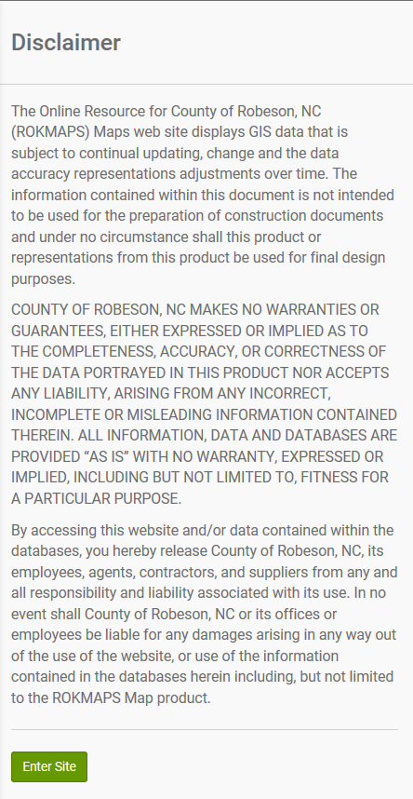

Click on Map Layers
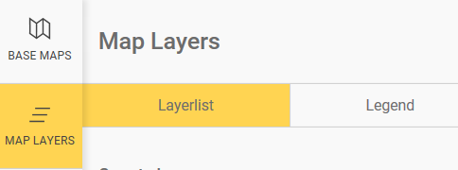

County Imagery
Click on Orthos
Aerials 2017 Trasparency; Slide bar all the way over to the right.
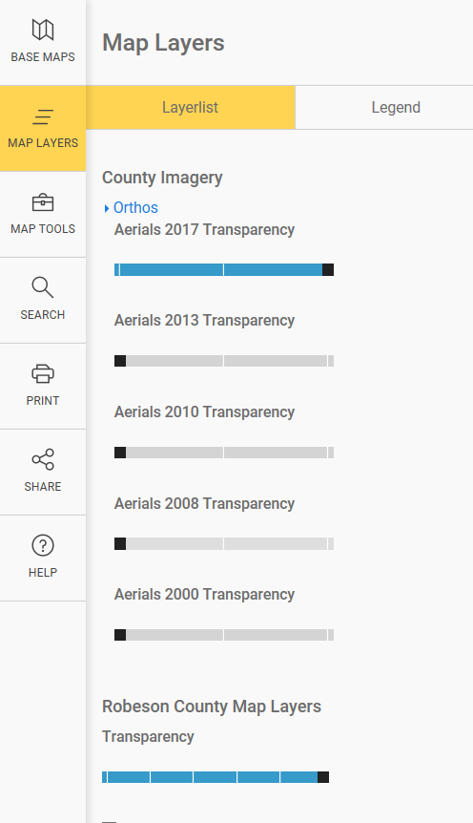
Click on Search, Click on Drop Down Menu, Select Parcels – Map Number
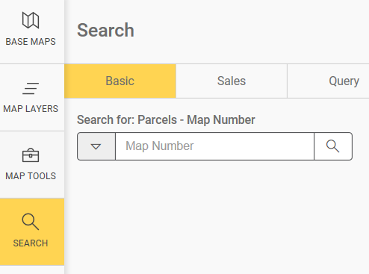
Drop Down Menu Enter Parcel Number from Surplus List

View upcoming Robeson County Tax Foreclosures Sales at:
http://co.robeson.nc.us/departments-p-z/tax/

